Title or Task: | Using Metaphors in Computers  
Description: | Shows sample of metaphors
Files Required | Internet icons
Suitable for Classes: | All classes
Area: | Technology & Enterprise
Teacher: | Mr Peter Faulks
Timeline | 1 lesson
Date Due: | today
Task Brief: | Find suitable metaphors
Outcomes: | Understand the use of icons and metaphors

Items highlighted in yellow are tasks for you to complete
Items in Blue italics are help tips

Worksheet Metaphor

Definition of Metaphor
Metaphor is a figure of speech that makes an implicit, implied, or hidden comparison between two things that are unrelated, but which share some common characteristics. In other words, a resemblance of two contradictory or different objects is made based on a single or some common characteristics.
In simple English, when you portray a person, place, thing, or an action as being something else, even though it is not actually that “something else,” you are speaking metaphorically.

For example, the phrase, “My brother is the black sheep of the family,” is a metaphor because he is not a sheep, nor is he black. However, we can use this comparison to describe an association of a black sheep with that person. A black sheep is an unusual animal, which typically stays away from the herd, and the person being described shares similar characteristics.

Furthermore, a metaphor develops a comparison that is different from a simile, in that we do not use “like” or “as” to develop a comparison in a metaphor. It actually makes an implicit or hidden comparison and not an explicit one.
Reference
https://literarydevices.net/metaphor/

So how do we use metaphors in computing

We use Icons

The word "icon" is derived from the Greek word eikon, meaning likeness or portrait. It was adopted by the computer world in the early 1980's as a means to help users find desired programs on their computer. While many icons are direct graphic renderings of company names, such as Apple's bitten apple icon (which quietly alludes to the Book of Genesis), programs such as Windows Movie Maker often use the image of something directly associated with the content, in this case a film reel (though the Maker cannot edit celluloid film!). If you look around, you'll find many icons are actually carefully chosen metaphors, such as WinAmp's lightning bolt or Nero's flame. An icon is a program's tatooed face in a software crowd, conveying an individual message about itself that can be recognized instantly.

Explain what you think the following metaphors mean


Answer HELP
Answer GO Back Answer GO Forward
Answer HOME Answer INFORMATION
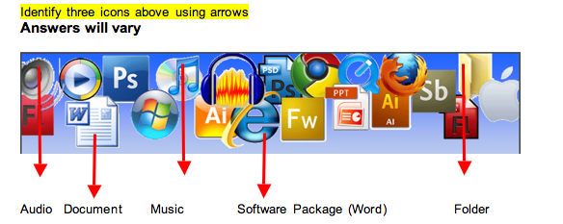

And write what you believe they refer to

A computer or communication header

From the list below find a metaphor that would suit the description
(use Clip Art or the Internet)

Answers will vary

Metaphor or Icon | Description
 | Bus: Bits commute each day on a data bus. Data is a group of objects.
 | Window: Opening a new window lets more enlightening in! A program exists in an outside space.
 | Frame: Frames compartmentalize screen space. An overlap of space is an (undesirable) overlap of concept.
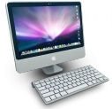 | Desktop: My desktop is cluttered with icons. A visual surface is a physical surface.
 | Open/Close: Windows, programs and ports may be opened or closed. To open is to start, and to be open is to be susceptible to change.
 | File: A corrupt file wreaks havoc on the computer. Data is physical and discrete, occupying space.
 | Folder: A folder may have any number of files within. Files are objects that can be grouped.
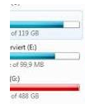 | Space: I've not much space left on my hard drive. Data takes up finite physical space.
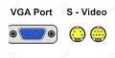 | Port: A port is a transfer point for shipping data. Data transfers on a liquid. But use a computer port.
 | Tools: A program's tools never need sharpening! Data is physically altered by a program.
 | Cut: I cut out part of a speech by Mayor Nagin. Data on the screen is as if on paper.
 | Clipboard: The excerpt sat on my clipboard awaiting pasting. Data may be physically picked up and held.

Insert some icons or metaphos for the following
Need help just ask

Making a phone call



Using a CD

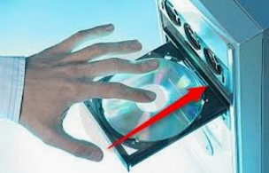

Pointing at something



Save this document

Need help just ask

